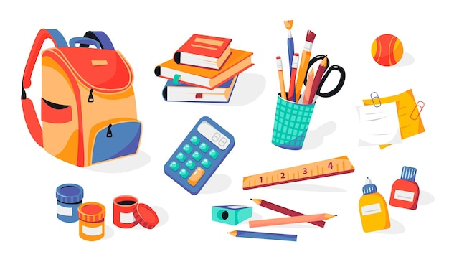
Pre-Kindergarten: 3 Glue Sticks (unscented), 3 Crayola Crayons 8 color pack, 1 Crayola Crayons 24 color pack, Pocket Folder, Pencil Box, 2 Boxes of Tissues, 1 Pack of Plastic spoons, Clorox Disinfecting Wipes, Small Paper Plates, Flushable Wipes, Baby Wipes, Backpack ( No Wheels)
Kindergarten: 1 Backpack/School Bag, 10 Glue Sticks, 4 boxes of Crayola Crayons (24 count) Please buy Crayola brand, 1 Dozen Pencils # 2, 1 Pocket Folder, 1 Pencil Box, 3 Boxes of Tissues, 1 Package of Plastic Spoons, 1 Container of Clorox Disinfecting Wipes, 1 Bottle Hand Sanitizer, 1 Package of Napkins (With the exception of the first six items on the list, the above supplies will be used in the classroom by all students. Therefore, it is not necessary to put your child’s name on the items)
First Grade: 1 Box of 24 Crayola Crayons, 1 Pencil Box (not bag), 1 Spiral 1 Subject Notebook, 1 Big Pink Eraser, 1 Pair of Scissors, 1 Pair of Headphones/Earbuds, 1 Folder, 4 Jumbo Elmer’s Glue Sticks(extra are appreciated), 3 Boxes of Tissues (extra are appreciated), Plastic silverware and Disinfecting Wipes
Second Grade: 2 Boxes Crayola Crayons (24 pack), 1 Pencil Box, 2 Boxes #2 Lead Pencils, 2 Pocket Folders, 3 Glue Sticks, I Pair Student Scissors, 1 Package Pencil Top Erasers, 2 Packages Loose Leaf Notebook Paper (wide rule), 3 Boxes of Tissues, 1 Pair of Headphones, 1 Package Coffee Filters (snack), 1 Package small paper plates (snack), 1 Package Plastic Spoons (snack)
Third Grade: 3 pks.#2 wooden pencils, 2-pkgs. Pencil top erasers, 2 boxes Crayons-24 count, 1 pkg. dry erase markers, 1 pkg. washable markers, 1 pkg. colored pencils, 2 glue sticks,1 pair of scissors, 3 two pocket folders, 1 pencil box, 2 large boxes of tissues, 1 container of Germ X, 1 container of Clorox wipes, Earbuds
Fourth Grade: Glue sticks, Tissues, Clorox Wipes, Paper cups, Pencils, Paper plates, Plastic Forks & Spoons, Hand Sanitizer, Pencil Box, Two Pocket Folders, Earbuds, Crayons
Fifth Grade: Pencils #2, Markers, Colored pencils, Glue sticks, Scissors, Notebooks, Lined paper, Earbuds & headphones for themselves
Sixth Grade: Tissues, Pencils, Headphones, Erasable markers, Erasers
Ms. Scott’s Class: Ziploc Sandwich bags, Ziploc Quart Size bags, Ziploc Gallon Size bags, Wet/Dry Swiffer pads, Tissues, Napkins (All items can be generic brands)

